11 Human Biology Protein Synth and Reproductive System Test

Name: _____________________________ Mark: /80

**Part one – multiple choice**

1. The seminiferous tubules are long and convoluted to:

a) increase the area available for sperm storage

b) increase surface area to volume ratio to allow for efficient diffusion

c) fit into a smaller space

d) allow for a greater number of spermatogonium

2. What is the function of cilia in the fallopian tube?

a) To provide nutrients for the ova.

b) To produce ova.

c) To lubricate the fallopian tube.

d) To guide ova along the fallopian tube.

3. DNA polymerase is used for:

a) the joining of amino acids

b) unzipping mRNA strands

c) the joining of codons with anti-codons

d) none of the above

4. What is the function of the testes?

a) Produces testosterone and spermatozoa.

b) Makes sperm and oestrogen.

c) Allows sperm to mature before moving into the vas deferens.

d) Produces luteinising hormone and testosterone.

5. Which of the following is **not** true?

a) The male gamete is spermatozoa.

b) The female gonad is the ovary.

c) Gametes are diploid.

d) Gametes are sex cells.

6. The movement of mature mRNA to the cytosol via the nuclear pore signals:

a) the end of fertility for all women

b) the end of transcription

c) the end of translation

d) the end of times... pack your bags it the apocalypse

7 Which of the following hormones causes development of secondary sexual characteristics in males?

a) follicle stimulating hormone

b) oestrogen

c) testosterone

d) luteinizing hormone

8. The ovarian follicle secretes the hormone:

a) oestrogen

b) follicle stimulating hormone

c) progesterone

d) luteinizing hormone

9. The following are events leading to menstruation. Which is the PRIMARY event which sets the others in motion?

a) degeneration of the blood supply to the endometrium

b) degeneration or the corpus luteum

c) reduction in the blood concentrations of oestrogen and progesterone

d) reduction in the supply of Luteinising Hormone

10. RNA splicing is the:

a) production of RNA from free nucleotides

b) the removal of introns from mRNA

c) the removal of exons from mRNA

d) a cool ice-cream treat during hot summer days

11. Luteinising hormone and Follicle stimulating hormone:

a) are produced in the gonads of males and females

b) are hormones that specifically target the ovaries

c) are involved with the production of secondary sex characteristics and gamete formation.

d) Hormones that enable a person to perform sick moves on the dancefloor.

12. Where would you find the corona radiata?

a) In the tail of a spermatazoa

b) Surrounding the mature ovum

c) Protecting the ovary

d) none of the above

13. If Ratchet and Charley were to have children ;) what two processes ensure variation of the chromosomes of the gametes?

a) Non-disjunction and chiasmata

b) Multiple replication and crossing over

c) Random assortment and crossing over

d) Random assortment and Non disjuction

**Section 2 Short answer.**

1. Label the diagram below. (8 marks)

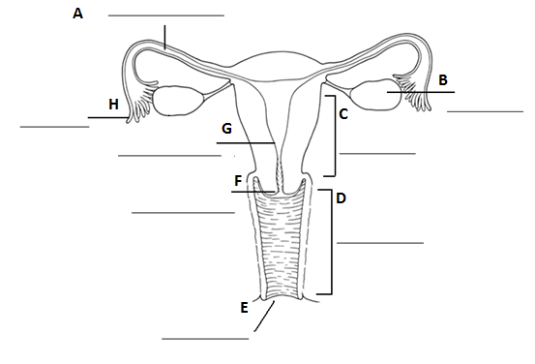

2. Label the diagram below. (13 marks)

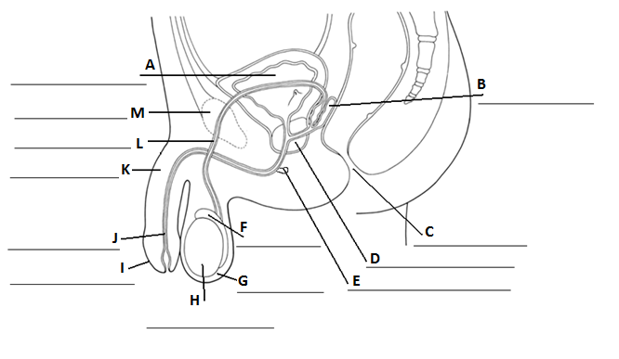

3. Fill in the table below. (8 marks)

|  |  |
| --- | --- |
| Structure | Function |
| Ovary |  |
| Fimbriae |  |
| Fallopian tube  (oviduct) |  |
| Uterus |  |
| Vagina |  |
| Testes |  |
| Epididymis |  |
| Urethra |  |

4. Fill in the table below on semen production (8 marks)

|  |  |  |
| --- | --- | --- |
| Organ | Produces | Function of substance |
|  | Sperm |  |
| Seminal vesicle |  |  |
|  | Milky alkaline fluid |  |
|  |  | Acts as lubricant |

5. Fill in the table below. (6 marks)

|  |  |  |  |
| --- | --- | --- | --- |
|  | Number of gametes produced by meiosis | Do hormones cause meiosis to begin? | When does meiosis occur? |
| Oogenesis |  |  |  |
| Spermatogenesis |  |  |  |

6. What are polar bodies? (1 mark)

___________________________________________________________________________________________

7. Where does sperm mature? (1 mark)

___________________________________________________________________________________________

8. How many viable eggs are produced during Oogenesis? (1 mark)

_____________________________________________________________________________ ______________

9. Using a table outline the similarities and differences between cell division for growth and repair and cell

division for the production of gametes. (5 marks)

10. List two secondary sexual characteristics that occur in females during puberty, that differs from males. (2 marks)

___________________________________________________________________________________________

___________________________________________________________________________________________

11. List three secondary sexual characteristics that occur in males during puberty, that differs from females. (2 marks)

___________________________________________________________________________________________

___________________________________________________________________________________________

Continues over the page.

12. Fill in the table below. (15 marks)

|  |  |  |  |
| --- | --- | --- | --- |
| Hormone | Where it is secreted from | Target organ | Effect of hormone |
| Follicle Stimulating Hormone |  |  |  |
| Luteinising hormone |  |  |  |
| Oestrogen |  |  |  |
| Progesterone |  |  |  |
| Testosterone |  |  |  |